🔍 TDD vs BDD — What’s the Difference?
To enhance understanding, here are visual representations of both methodologies:
📘 Visual: Test-Driven Development (TDD)
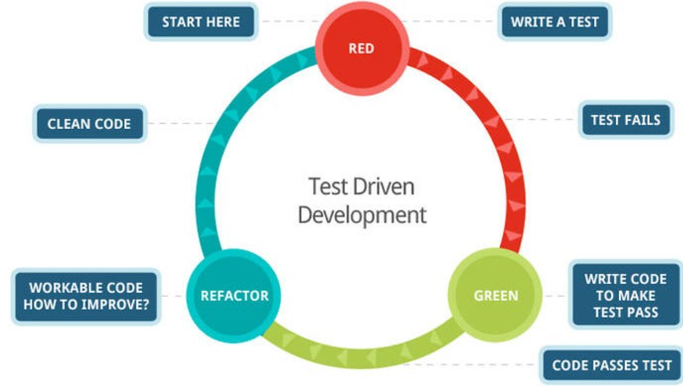
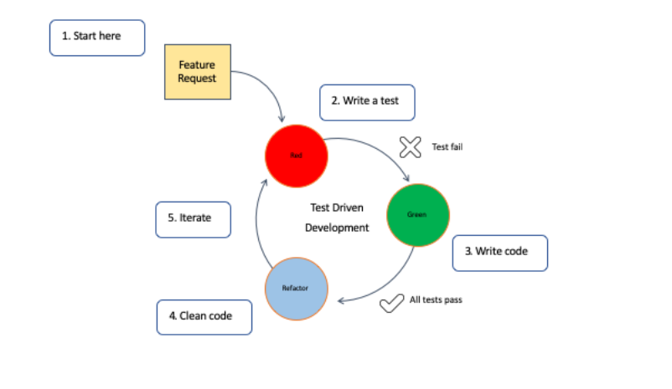
📗 Visual: Behaviour-Driven Development (BDD)
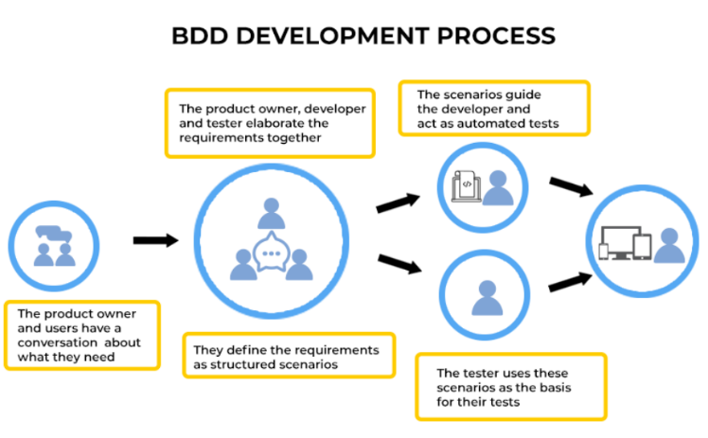
🆚 TDD vs BDD — Side-by-Side Comparison
Feature | TDD (Test-Driven Development) | BDD (Behaviour-Driven Development)
Primary Focus | Code correctness | Application behaviour from user's perspective
Written By | Developers | Developers + QA + Business Stakeholders
Language Used | Technical test cases | Natural language (Given-When-Then)
Test Style | Unit tests | Acceptance & integration tests
Main Goal | Ensure code does what developer expects | Ensure system behaves as business expects
Approach | Write failing test → write code → refactor | Define behaviour → write scenario → automate → implement
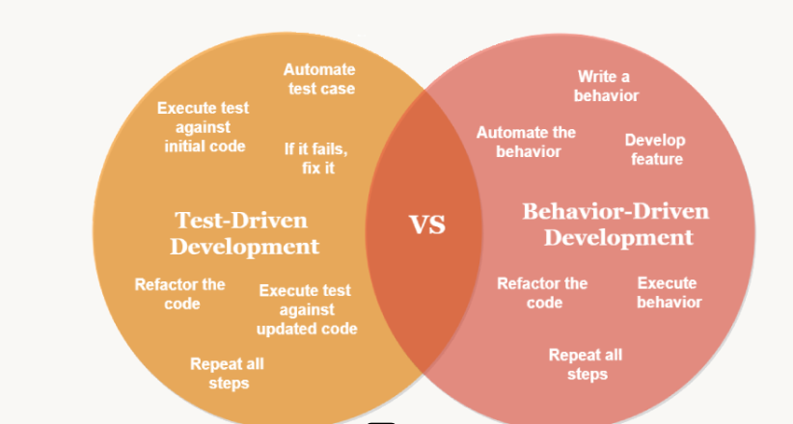
How Each Method Works:
🔹 Test-Driven Development (TDD) Workflow
1. RED → Write a failing unit test
2. GREEN → Write minimum code to pass test
3. REFACTOR → Improve structure while keeping tests green
Benefits of TDD
- Produces cleaner, modular code
- Reduces bugs early
- Ensures strong unit-level coverage
- Encourages good design practices
Best For
- Backend logic
- Algorithms
- Libraries, APIs
- Systems requiring high reliability

🔹 Behaviour-Driven Development (BDD) Workflow:
1. DISCUSS → Product owner + QA + dev clarify behaviour
2. DESCRIBE → Write Given / When / Then scenarios
3. AUTOMATE → Convert scenarios into executable tests
4. DEVELOP → Implement code until scenarios pass
Benefits of BDD:
- Removes ambiguity in requirements
- Aligns business + development
- Provides living documentation
- Great for functional testing
Best For:
- Customer-facing applications
- Cross-functional agile teams
- Systems needing clear acceptance criteria
- Web/mobile UI flows

🏁 When to Use What?
✔ Choose TDD when:
- You are building complex logic
- You want highly stable, modular code
- Your domain is algorithm-heavy or backend-heavy
✔ Choose BDD when:
- Requirements come from non-technical stakeholders
- You build user-facing applications with workflows
- Communication clarity is critical
- You want acceptance criteria to be executable tests

